**Smart Irrigation System using Internet of Things (IoT)**

**Project report by Manoj R**

**Sapthagiri College of Engineering**

**Introduction**

India is the country of village and agriculture plays an important role for development of country. In our country, agriculture depends on the monsoons which has insufficient source of water. So the irrigation is used in agriculture field. In Irrigation system, depending upon the soil type, water is provided to plant. In agriculture, two things are very important, first to get information of about the fertility of soil and second to measure moisture content in soil. Nowadays, for irrigation, different techniques are available which are used to reduce the dependency of rain. And mostly this technique is driven by electrical power and on/off scheduling. In this technique, water level indicator placed in water reservoir and soil moisture sensors are placed root zone of plant and near the module and gateway unit handles the sensor information and transmit data to the controller which in turns the control the flow of water through the valves

**Motivation**

For continuously increasing demand and decrease in supply of food necessities, it’s important to rapid improvement in production of food technology. Agriculture is only the source to provide this. This is the important factor in human societies to growing and dynamic demand in food production. Agriculture plays the important role in the economy and development, like India. Due to lack of water and scarcity of land water result the decreasing volume of water on earth, the farmer use irrigation. Irrigation may be defined as the science of artificial application of water to the land or soil that means depending on the soil type, plant are to be provided with water.

**Area of Utility**

1. The primary focus of this project is to help the farmers and reduce their work.
2. This module can be implemented in perennial plant irrigation land and gardening land.

**Literature Survey**

In irrigation field, soil moisture sensor, temperature sensors are placed in root of plant and microcontroller handles the sensor information and transmits data. One algorithm was developed to measure threshold values of temperature sensor and soil moisture sensor that was programmed into a microcontroller to control water quantity. A model of automatic irrigation system which is based on microcontroller and solar power was used only for source of power supply. Various sensor are placed in paddy field. Sensors sense water level continuously and give the information to farmer through cellular phone. Farmer controls the motor using cellular phone without going in paddy field. If the water level reaches at danger level, automatically motor will be off without conformation of farmer.

**Project Component Setup**

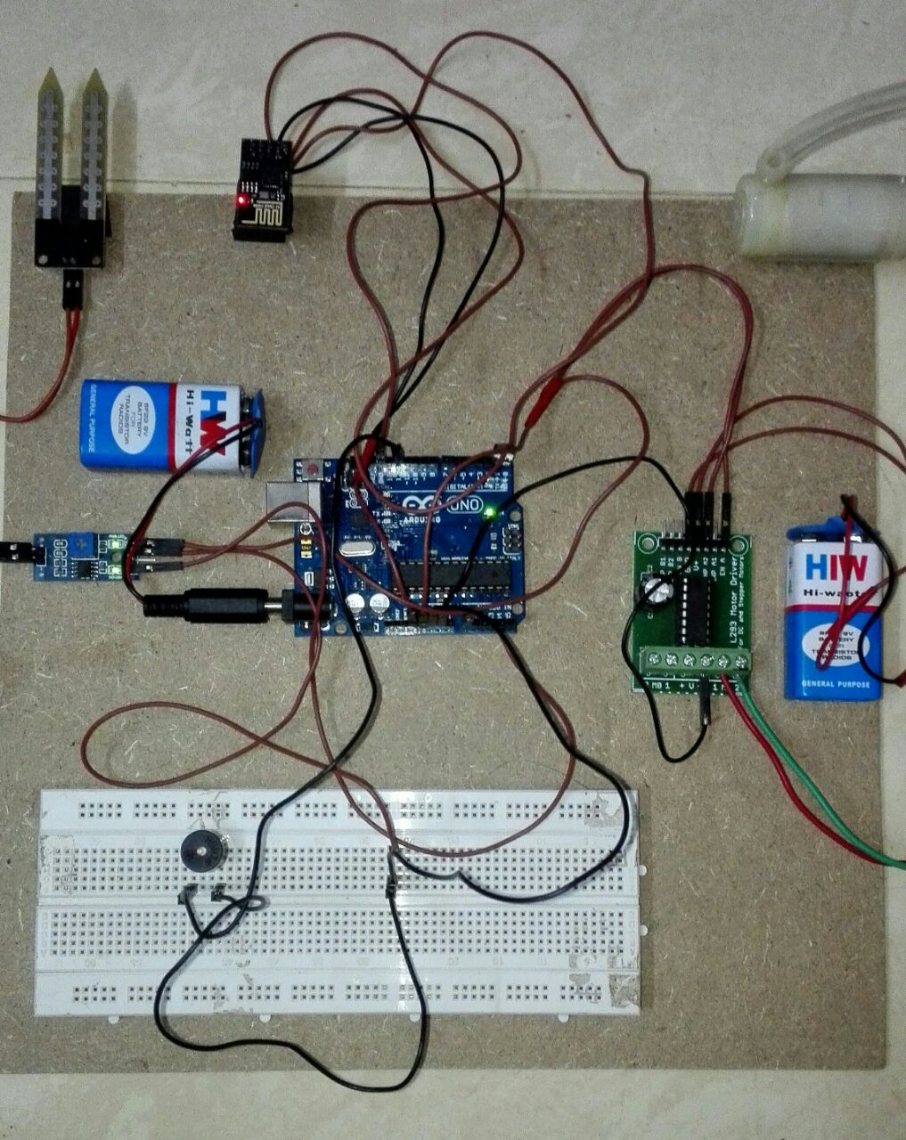

**Major Components Required:**

**Arduino Uno Board**

Arduino is a prototype platform (open-source) based on an easy-to-use hardware and software. It consists of a circuit board, which can be programmed (referred to as a microcontroller) and a readymade software called Arduino IDE (Integrated Development Environment), which is used to write and upload the computer code to the physical board.

* **Technical Specification of Arduino:**

Microcontroller ATmega328

Operating Voltage 5V

Input Voltage (recommended) 7-12V

Input Voltage (limits) 6-20V

Digital I/O Pins 14 (of which 6 provide PWM output)

Analog Input Pins 6

DC Current per I/O Pin 40 mA DC

Current for 3.3V Pin 50 mA

Flash Memory 32 KB (ATmega328) of which 0.5 KB used by boot loader

SRAM 2 KB (ATmega328)

EEPROM 1 KB (ATmega328)

Clock Speed 16 MHz

* **Communication**

The Arduino Uno has a number of facilities for communicating with a computer, another Arduino, or other microcontrollers. The ATmega328 provides UART TTL (5V) serial communication, which is available on digital pins 0 (RX) and 1 (TX). An ATmega16U2 on the board channels this serial communication over USB and appears as a virtual com port to software on the computer. The '16U2 firmware uses the standard USB COM drivers, and no external driver is needed. However, on Windows, a .inf file is required. The Arduino software includes a serial monitor which allows simple textual data to be sent to and from the Arduino board. The RX and TX LEDs on the board will flash when data is being transmitted via the USB-to-serial chip and USB connection to the computer (but not for serial communication on pins 0 and 1). A Software Serial library allows for serial communication on any of the Uno's digital pins. The ATmega328 also supports I2C (TWI) and SPI communication. The Arduino software includes a Wire library to simplify use of the I2C bus; see the documentation for details. For SPI communication, use the SPI library.

* **Power**

The Arduino Uno can be powered via the USB connection or with an external power supply. The power source is selected automatically. External (non-USB) power can come either from an AC-to-DC adapter (wall-wart) or battery. The adapter can be connected by plugging a 2.1mm center-positive plug into the board's power jack. Leads from a battery can be inserted in the Gnd and Vin pin headers of the POWER connector. The board can operate on an external supply of 6 to 20 volts. If supplied with less than 7V, however, the 5V pin may supply less than five volts and the board may be unstable. If using more than 12V, the voltage regulator may overheat and damage the board. The recommended range is 7 to 12 volts. The power pins are as follows: • VIN. The input voltage to the Arduino board when it's using an external power source (as opposed to 5 volts from the USB connection or other regulated power source). You can supply voltage through this pin, or, if supplying voltage via the power jack, access it through this pin. • 5V.This pin outputs a regulated 5V from the regulator on the board. The board can be supplied with power either from the DC power jack (7 - 12V), the USB connector (5V), or the VIN pin of the board (7-12V). Supplying voltage via the 5V or 3.3V pins bypasses the regulator, and can damage your board. • 3V3. A 3.3 volt supply generated by the on-board regulator. Maximum current draw is 50 mA. • GND. Ground pins.

**Why Arduino?**

Thanks to its simple and accessible user experience, Arduino has been used in thousands of different projects and applications. The Arduino software is easy-to-use for beginners, yet flexible enough for advanced users. It runs on Mac, Windows, and Linux. Teachers and students use it to build low cost scientific instruments, to prove chemistry and physics principles, or to get started with programming and robotics. Designers and architects build interactive prototypes, musicians and artists use it for installations and to experiment with new musical instruments. Makers, of course, use it to build many of the projects exhibited at the Maker Faire, for example. Arduino is a key tool to learn new things. Anyone - children, hobbyists, artists, programmers - can start tinkering just following the step by step instructions of a kit, or sharing ideas online with other members of the Arduino community. There are many other microcontrollers and microcontroller platforms available for physical computing. Parallax Basic Stamp, Netmedia's BX-24, Phidgets, MIT's Handyboard, and many others offer similar functionality. All of these tools take the messy details of microcontroller programming and wrap it up in an easy-to-use package. Arduino also simplifies the process of working with microcontrollers, but it Offers some advantage for teachers, students, and interested amateurs over other systems: Inexpensive - Arduino boards are relatively inexpensive compared to other microcontroller platforms. The least expensive version of the Arduino module can be assembled by hand, and even the preassembled Arduino modules cost less than $50

**ESP8266 Wi-Fi Module**

Wi-Fi stands for Wireless Fidelity. Through Wi-Fi the consumer can set changes in threshold value, he can ON and OFF the energy meter.

Time to time the readings of units and cost are displayed on webpage. Consumer can access the Arduino board and meter with help of Wi-Fi.

ESP8266 offers a complete and self-contained Wi-Fi networking solution, allowing it to either host the application or to offload all Wi-Fi networking functions from another application processor.

It has integrated cache to improve the performance of the system in such applications, and to minimize the memory requirements

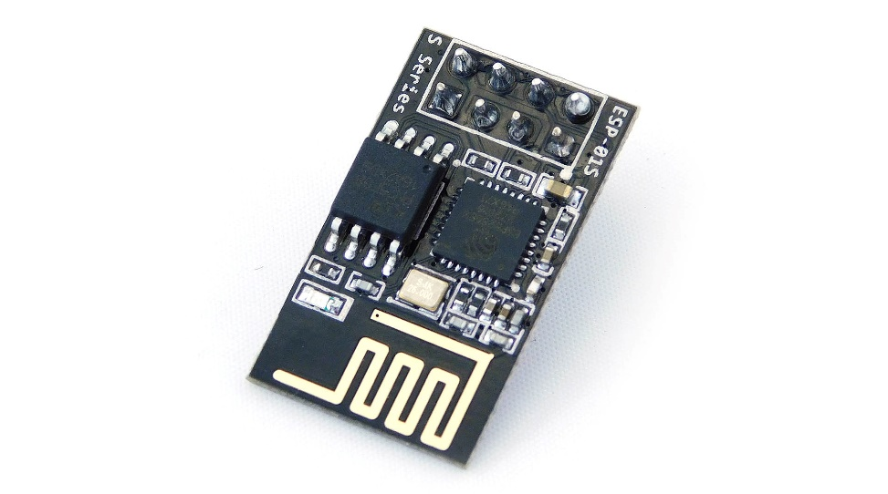

**Specifications**

• Embedded with a 32 bit microcontroller

• Working power range 3 to 3.6V.

• 802.11 b/g/n protocol with a capability of 2.4 GHz.

• Wi-Fi Direct (P2P), soft-AP

• Integrated TCP/IP protocol stack

• SPI and UART communication is enabled.

• Power down leakage current of < 10uA

• Integrated low power 32-bit CPU could be used as application processor

• Wake up and transmit packets in < 2ms

**MOTOR DRIVER**

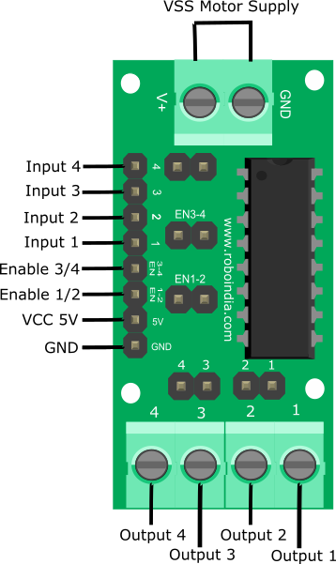

The Motor Driver is a module for motors that allows you to control the working speed and direction of two motors simultaneously. This Motor Driver is designed and developed based on L293D IC. L293D is a 16 Pin Motor Driver IC. This is designed to provide bidirectional drive currents at voltages from 5 V to 36 V.

**Soil Moisture Sensor**

A typical Soil Moisture Sensor consist of two components. A two legged Lead, that goes into the soil or anywhere else where water content has to be measured. This has two header pins which connect to an Amplifier/ A-D circuit which is in turn connected to the Arduino.

The Amplifier has a Vin, Gnd, Analog and Digital Data Pins. This means that you can get the values in both Analog and Digital forms.

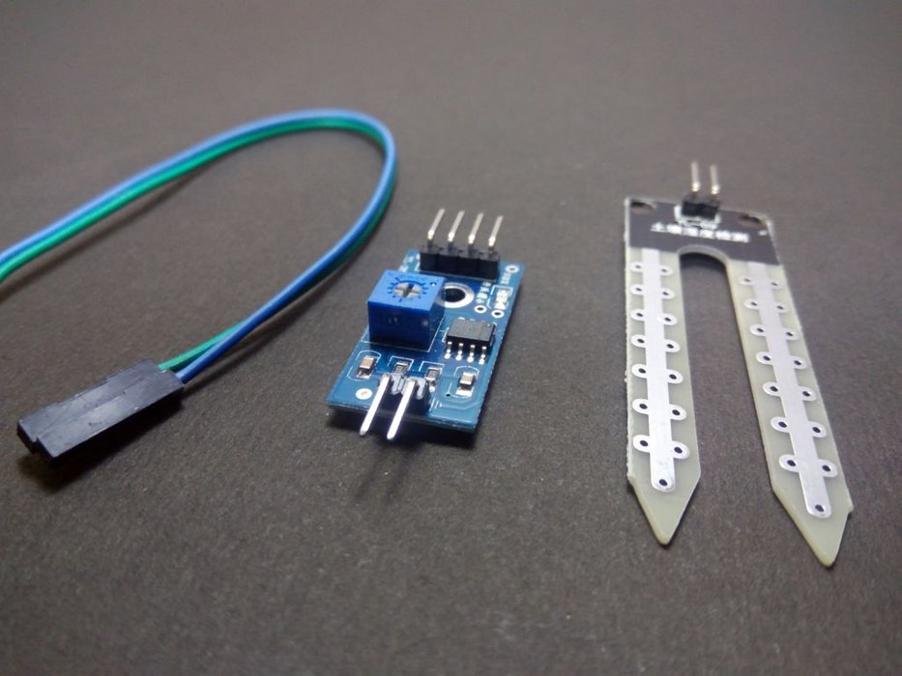

**DC MOTOR**

A **DC motor** is any of a class of rotary electrical machines that converts direct current electrical energy into mechanical energy. The most common types rely on the forces produced by magnetic fields. Nearly all types of DC motors have some internal mechanism, either electromechanical or electronic, to periodically change the direction of current flow in part of the motor.

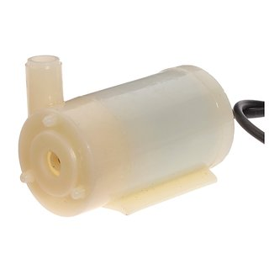

**Internet of Things(IoT)**

The Internet of Things (IoT) is the network of physical objects devices, vehicles,

buildings and other items embedded with electronics, software, sensors, and network

connectivity that enables these objects to collect and exchange data. The IoT allows objects to

be sensed and controlled remotely across existing network infrastructure, creating

opportunities for more direct integration of the physical world into computer-based systems,

and resulting in improved efficiency, accuracy and economic benefit, when IoT is augmented

with sensors and actuators, the technology becomes an instance of the more general class of

cyber physical systems, which also encompasses technologies such as smart grids, smart

homes, intelligent transportation and smart cities. Each thing is uniquely identifiable through

its embedded computing system but is able to interoperate within the existing Internet

infrastructure.

So, Internet of Things or IoT is an architecture that comprises specialized hardware

boards, Software systems, web APIs, protocols which together creates a seamless environment

which allows smart embedded devices to be connected to internet such that sensory data can

be accessed and control system can be triggered over internet.

Also, devices could be connected to internet using various means like Wi-Fi, Ethernet

and so on. Furthermore, devices may not be needed to be connected to internet independently.

Rather a cluster of devices could be created (for example a sensor network) and the base station

or the cluster head could be connected to internet. This leads to more abstract architecture for

communication protocols which ranges from high level to low level.

Most interestingly, these devices must be uniquely discovered. For unique discovery of

the devices in a Network, they need to have unique IP address. IoT devices essentially have

IPv6 addressing scheme. All these devices have either fixed or Subnet masked IP addresses of

type v6. Unique IP addresses makes IoT devices discoverable in the internet as independent

node. This is the most important concept to have in mind to understand IoT.

**Project Setup:**

* The Wi-Fi module ESP8266 is interfaced directly to the Arduino board through the Receiving and Transmitting pins of Arduino (i.e. 0 and 1) which is responsible to transmit the current status of the soil moisture and the pump to the ThingSpeak server.
* The dc motor pump is connected to the Arduino board through the use of motor driver. The main purpose of the driver is to supply the necessary current and voltage for the pump which is not possible by the Arduino.
* The soil moisture sensor is connected to the Analog pin of Arduino as the soil moisture value would be sensed continuously and may vary extensively.
* An indicator is provided to indicate the low status value of the soil moisture which indicated less moisture in the soil.

**Pin Setup of Arduino:**

**Module Module Pins Arduino Pins**

**ESP8266 Rx Tx**

**Tx Rx**

**Motor Vcc Vcc**

**Driver Gnd Gnd**

**A0 12**

**Motor +ve Vcc (Driver)**

**-ve Gnd (Driver)**

**Soil Sensor A0 A0**

**B0 Gnd**

**Project working:**

* The soil moisture sensor continuously monitors the status of the moisture level of the soil where the land has to be irrigated.
* The sensor value is monitored in the program with the threshold value below which the pump has to be energised and the water has to be supplies to the land.
* If the moisture level goes below certain point set in the program, the motor pump supplies the required amount of water.
* The status about the moisture and the water supply pump is continuously sent to the server where the online status can be monitored and controlled.
* After the supply of water to the land, the soil moisture is sensed and if it is above the threshold value, the motor pump is stopped and thus supplying only the required amount of water to the land.
* An extension to this project involves the use of LDR (Light Dependent Resistor) which senses the possibility of rain and avoids the water being pumped from the well so that water can be saved.
* The irrigation system can be remotely monitored and controlled using a mobile application without the need of farmers visiting the field more often to deal with the supply of water.

**Arduino Programming Algorithm**

The Arduino Programming mainly consists of two methods i.e. SETUP and LOOP. The SETUP method is used to initialize the Arduino pins in INPUT or OUTPUT mode. The LOOP method is continuously run through out the operation of the Arduino where the actual logic of the sensing and actuation can be written.

* **Baud rates for the proper flow of commands are set in both Arduino Uno and the ESP8266 module.**
* **The Wi-fi module is initialized by sending ‘AT’ Hayes command which responds with ‘OK’ if the module is ready to transfer the signals.**
* **If module responds with ‘OK’ message, it is connected to the Internet through the pre-set Wi-Fi id and Password.**
* **Sensor value is read and mapped to the values between 0 to 100.**
* **If the value of the moisture is well below a certain limit, the motor pump is energised.**
* **TCP connection to the server is setup through the Wi-Fi module to send the data.**
* **The UPDATE request to the server is made by updating the URL with the current status of the sensor and pump.**
* **The pump status and the moisture level in the soil is updated to the server.**

**External References:**

* **IoT based smart irrigation system and nutrient detection with disease analysis, :**[IEEE Region 10 Symposium (TENSYMP), 2017](http://ieeexplore.ieee.org/xpl/mostRecentIssue.jsp?punumber=8062174), **Electronic ISBN:** 978-1-5090-6255-3

# Intelligent irrigation system — An IOT based approach, [Innovations in Green Energy and Healthcare Technologies (IGEHT), 2017 International Conference](http://ieeexplore.ieee.org/xpl/mostRecentIssue.jsp?punumber=8053492)